LICEUL TEORETIC “MIHAIL KOGĂLNICEANU” VASLUI

LUCRARE PENTRU OBŢINEREA
ATESTATULUI PROFESIONAL

= profil matematică – informatică =

Profesor îndrumător,
Florica Ciurescu

Absolvent,
Turcu Mihnea Alexandru

Vaslui, 2022

Dezvoltarea si proiectarea jocuri lor si aplicatiilor in Godot Engine
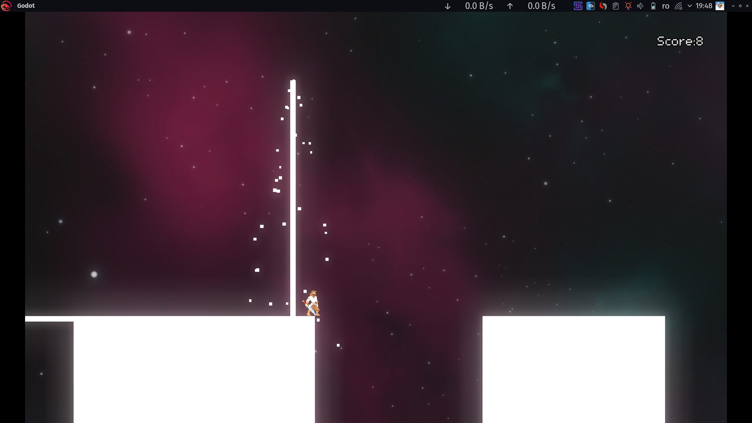

INTRODUCERE

Creare jocurilor cu un engine este de multe ori mai simpla si mai rapidă decat cu ajutorul unui limbaj de programare si al unui API grafic, fiind mai usoară si mai ușor de înțeles.
în unele cazuri este necesară utilizarea unui astfel tip de unealtă deoarece sunt anumite utilitati care nu pot fi realizate in timp util altfel, exemplu ar fi exportarea aplicatiei realizate pe diferite platforme.
Un dezavantaj este viteza cu care ruleaza programul deoarece engine-ul nu este optimizat special pentru proiectul tau si particularitatile pe care le contine acesta.
Intelegerea functionarii unui engine este utila celor care vor sa aprofundeze dezvoltarea de jocuri/aplicatii si programarea modularizata sau persoanelor care vor sa profeseze in industria jocurilor video sau a dezvoltarii de aplicatii.
Aceasta lucrare isi propune prezentarea nu doar a consideratiilor teoretice, dar si a unui proiect realizat intr-un astfel de engine, Godot, cu explicatii detaliate si a implementarilor in limbajul GDScript.
Proiectul constă intr-un joc in care jucătorului îi este atribuit un personaj pe care trebuie sa il treaca in siguranta de pe un pilon pe celalalt.

CONSIDERAȚII TEORETICE
10-15 PAGINI

Engine-ul Godot
Godot Engine e un game engine plin de utilități, cross-platform folosist pentru crearea jocurilor si aplicatiilor 2D si 3D printr-o interfață unificata. Acesta asigură un set complet de unelte uzuale, astfel utilizatorul se poate concentra pe crearea jocurilor fara sa reinventeze roata.
Jocurile sau aplicațiile pot fi exportate printr-un “click” pentru diferite platforme, inclusiv platformele majore de desktop (Linux, macOS, Windows) precum si cele pentru telefoanele mobile(Android, IOS) cat si cele bazate pe web(HTML5).

Godot este complet gratis si are sursa libera sub licența permisivă MIT. Jocurile sau aplicațiile utilizatorilor sunt ale lor si numai ale lor. Dezvoltarea engine-ului e complet independent si condusă de comunitatate, lăsând utilizatorii sa contureze engine-ul astfel încat să le întâlnească așteptările

Acest joc a fost scris in limbajele specifice engine-ului Godot si anume GDScript si TSCN.

Așa arată sintaxa limbajului GDScript:
program = [ inheritance NEWLINE ] [ className ] { topLevelDecl } ;

inheritance = "extends" ( IDENTIFIER | STRING ) { "." IDENTIFIER } ;
className = "class_name" IDENTIFIER [ "," STRING ] NEWLINE ;

topLevelDecl
= classVarDecl
| constDecl
| signalDecl
| enumDecl
| methodDecl
| constructorDecl
| innerClass
| "tool"
;

classVarDecl = [ "onready" ] [ export ] "var" IDENTIFIER [ ":" typeHint ]
[ "=" expression ] [ setget ] NEWLINE ;
setget = "setget" [ IDENTIFIER ] [ "," IDENTIFIER] ;
export = "export" [ "(" [ BUILTINTYPE | IDENTIFIER { "," literal } ] ")" ] ;
typeHint = BUILTINTYPE | IDENTIFIER ;

constDecl = "const" IDENTIFIER [ ":" typeHint ] "=" expression NEWLINE ;

signalDecl = "signal" IDENTIFIER [ signalParList ] NEWLINE ;
signalParList = "(" [ IDENTIFIER { "," IDENTIFIER } ] ")" ;

enumDecl = "enum" [ IDENTIFIER ] "{" [ IDENTIFIER [ "=" INTEGER ]
{ "," IDENTIFIER [ "=" INTEGER ] } [ "," ] ] "}" NEWLINE ;

methodDecl = [ rpc ] [ "static" ] "func" IDENTIFIER "(" [ parList ] ")"
[ "->" typeHint] ":" stmtOrSuite ;
parList = parameter { "," parameter } ;
parameter = [ "var" ] IDENTIFIER [ ":" typeHint ] [ "=" expression ] ;
rpc = "remote" | "master" | "puppet"
| "remotesync" | "mastersync" | "puppetsync";

constructorDecl = "func" IDENTIFIER "(" [ parList ] ")"
[ "." "(" [ argList ] ")" ] ":" stmtOrSuite ;
argList = expression { "," expression } ;

innerClass = "class" IDENTIFIER [ inheritance ] ":" NEWLINE
INDENT [ inheritance NEWLINE ] topLevelDecl { topLevelDecl } DEDENT ;

stmtOrSuite = stmt | NEWLINE INDENT suite DEDENT ;
suite = stmt { stmt };

stmt
= varDeclStmt
| ifStmt
| forStmt
| whileStmt
| matchStmt
| flowStmt
| assignmentStmt
| exprStmt
| assertStmt
| yieldStmt
| preloadStmt
| "breakpoint" stmtEnd
| "pass" stmtEnd
;
stmtEnd = NEWLINE | ";" ;

ifStmt = "if" expression ":" stmtOrSuite { "elif" expression ":" stmtOrSuite }
[ "else" ":" stmtOrSuite ] ;
whileStmt = "while" expression ":" stmtOrSuite;
forStmt = "for" IDENTIFIER "in" expression ":" stmtOrSuite ;

matchStmt = "match" expression ":" NEWLINE INDENT matchBlock DEDENT;
matchBlock = patternList ":" stmtOrSuite { patternList ":" stmtOrSuite };
patternList = pattern { "," pattern } ;
(* Note: you can't have a binding in a pattern list, but to not complicate the
grammar more it won't be restricted syntactically *)
pattern = literal | BUILTINTYPE | CONSTANT | "_" | bindingPattern
| arrayPattern | dictPattern ;
bindingPattern = "var" IDENTIFIER ;
arrayPattern = "[" [ pattern { "," pattern } [ ".." ] ] "]" ;
dictPattern = "{" [ keyValuePattern ] { "," keyValuePattern } [ ".." ] "}" ;
keyValuePattern = STRING [ ":" pattern ] ;

flowStmt
= "continue" stmtEnd
| "break" stmtEnd
| "return" [ expression ] stmtEnd
;

assignmentStmt = subscription "=" expression stmtEnd;
varDeclStmt = "var" IDENTIFIER [ "=" expression ] stmtEnd;

assertStmt = "assert" "(" expression [ "," STRING ] ")" stmtEnd ;
yieldStmt = "yield" "(" [ expression "," expression ] ")" ;
preloadStmt = "preload" "(" CONSTANT ")" ;

(* This expression grammar encodes precedence. Items later in the list have
higher precedence than the ones before. *)
exprStmt = expression stmtEnd ;
expression = cast [ "[" expression "]" ] ;
cast = ternaryExpr [ "as" typeHint ];
ternaryExpr = logicOr [ "if" logicOr "else" logicOr ] ;
logicOr = logicAnd { ( "or" | "||" ) logicAnd } ;
logicAnd = logicNot { ( "and" | "&&" ) logicNot };
logicNot = ( "!" | "not" ) logicNot | in;
in = comparison { "in" comparison };
comparison = bitOr { ( "<" | ">" | "<=" | ">=" | "==" | "!=" ) bitOr } ;
bitOr = bitXor { "|" bitXor } ;
bitXor = bitAnd { "^" bitAnd } ;
bitAnd = bitShift { "&" bitShift } ;
bitShift = minus { ( "<<" | ">>" ) minus } ;
minus = plus { "-" plus } ;
plus = factor { "+" factor } ;
factor = sign { ( "*" | "/" | "%" ) sign } ;
sign = ( "-" | "+" ) sign | bitNot ;
bitNot = "~" bitNot | is ;
is = call [ "is" ( IDENTIFIER | BUILTINTYPE ) ] ;
call = attribute [ "(" [ argList ] ")" ];
attribute = subscription { "." IDENTIFIER } ;
subscription = primary [ "[" expression "]" ] ;
primary = "true" | "false" | "null" | "self" | literal | arrayDecl
| dictDecl | "(" expression ")" ;

literal = STRING | NUMBER | IDENTIFIER | BUILTINTYPE
| "PI" | "TAU" | "NAN" | "INF" ;
arrayDecl = "[" [ expression { "," expression } "," ] "]" ;
dictDecl = "{" [ keyValue { "," keyValue } "," ] "}" ;
keyValue
= expression ":" expression
| IDENTIFIER "=" expression
;

Fizica din engine-ul Godot

Physics introduction
În dezvoltarea jocurilor, ai nevoie de multe ori să poți afla dacă două obiecte se intersectează sau intră in contact. Aceasta este cunoscută ca collision dectection. Când o coliziune este detectată, deobicei vrei să se întample ceva. Asta este cunoscută ca collision response

In game development, you often need to know when two objects in the game intersect or come into contact. This is known as collision detection. When a collision is detected, you typically want something to happen. This is known as collision response.
Godot offers a number of collision objects in 2D and 3D to provide both collision detection and response. Trying to decide which one to use for your project can be confusing. You can avoid problems and simplify development if you understand how each works and what their pros and cons are.
In this guide, you will learn:
- Godot's four collision object types
- How each collision object works
- When and why to choose one type over another
Note
This document's examples will use 2D objects. Every 2D physics object and collision shape has a direct equivalent in 3D and in most cases they work in much the same way.

Collision objects
Godot offers four kinds of physics bodies, extending CollisionObject2D:
- Area2D
Area2D nodes provide detection and influence. They can detect when objects overlap and can emit signals when bodies enter or exit. An Area2D can also be used to override physics properties, such as gravity or damping, in a defined area.
The other three bodies extend PhysicsBody2D:
- StaticBody2D
A static body is one that is not moved by the physics engine. It participates in collision detection, but does not move in response to the collision. They are most often used for objects that are part of the environment or that do not need to have any dynamic behavior.
- RigidBody2D
This is the node that implements simulated 2D physics. You do not control a RigidBody2D directly, but instead you apply forces to it (gravity, impulses, etc.) and the physics engine calculates the resulting movement. Read more about using rigid bodies.
- KinematicBody2D
A body that provides collision detection, but no physics. All movement and collision response must be implemented in code.

Physics material
Static bodies and rigid bodies can be configured to use a physics material. This allows adjusting the friction and bounce of an object, and set if it's absorbent and/or rough.

Collision shapes
A physics body can hold any number of Shape2D objects as children. These shapes are used to define the object's collision bounds and to detect contact with other objects.
Note
In order to detect collisions, at least one Shape2D must be assigned to the object.
The most common way to assign a shape is by adding a CollisionShape2D or CollisionPolygon2D as a child of the object. These nodes allow you to draw the shape directly in the editor workspace.
Important
Be careful to never scale your collision shapes in the editor. The "Scale" property in the Inspector should remain (1, 1). When changing the size of the collision shape, you should always use the size handles, not the Node2D scale handles. Scaling a shape can result in unexpected collision behavior.
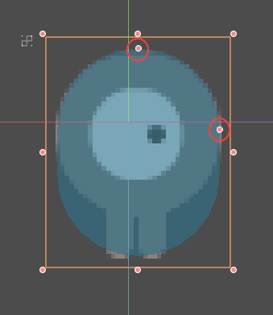

Physics process callback
The physics engine may spawn multiple threads to improve performance, so it can use up to a full frame to process physics. Because of this, the value of a body's state variables such as position or linear velocity may not be accurate for the current frame.
In order to avoid this inaccuracy, any code that needs to access a body's properties should be run in the Node._physics_process() callback, which is called before each physics step at a constant frame rate (60 times per second by default). This method will be passed a delta parameter, which is a floating-point number equal to the time passed in seconds since the last step. When using the default 60 Hz physics update rate, it will typically be equal to 0.01666... (but not always, see below).
Note
It's recommended to always use the delta parameter when relevant in your physics calculations, so that the game behaves correctly if you change the physics update rate or if the player's device can't keep up.

Collision layers and masks
One of the most powerful, but frequently misunderstood, collision features is the collision layer system. This system allows you to build up complex interactions between a variety of objects. The key concepts are layers and masks. Each CollisionObject2D has 20 different physics layers it can interact with.
Let's look at each of the properties in turn:
- collision_layer
This describes the layers that the object appears in. By default, all bodies are on layer 1.
- collision_mask
This describes what layers the body will scan for collisions. If an object isn't in one of the mask layers, the body will ignore it. By default, all bodies scan layer 1.
These properties can be configured via code, or by editing them in the Inspector.
Keeping track of what you're using each layer for can be difficult, so you may find it useful to assign names to the layers you're using. Names can be assigned in Project Settings -> Layer Names.
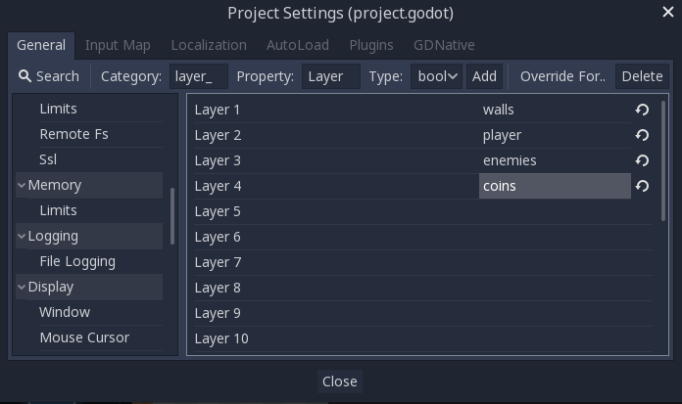

GUI example
You have four node types in your game: Walls, Player, Enemy, and Coin. Both Player and Enemy should collide with Walls. The Player node should detect collisions with both Enemy and Coin, but Enemy and Coin should ignore each other.
Start by naming layers 1-4 "walls", "player", "enemies", and "coins" and place each node type in its respective layer using the "Layer" property. Then set each node's "Mask" property by selecting the layers it should interact with. For example, the Player's settings would look like this:
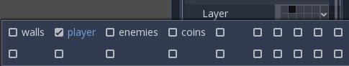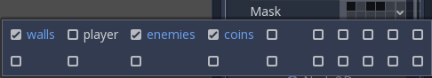

Code example
In function calls, layers are specified as a bitmask. Where a function enables all layers by default, the layer mask will be given as 0x7fffffff. Your code can use binary, hexadecimal, or decimal notation for layer masks, depending on your preference.
The code equivalent of the above example where layers 1, 3 and 4 were enabled would be as follows:
# Example: Setting mask value for enabling layers 1, 3 and 4

# Binary - set the bit corresponding to the layers you want to enable (1, 3, and 4) to 1, set all other bits to 0.
# Note: Layer 20 is the first bit, layer 1 is the last. The mask for layers 4,3 and 1 is therefore
0b00000000000000001101
# (This can be shortened to 0b1101)

# Hexadecimal equivalent (1101 binary converted to hexadecimal)
0x000d
# (This value can be shortened to 0xd)

# Decimal - Add the results of 2 to the power of (layer be enabled-1).
# (2^(1-1)) + (2^(3-1)) + (2^(4-1)) = 1 + 4 + 8 = 13
pow(2, 1) + pow(2, 3) + pow(2, 4)

Area2D
Area nodes provide detection and influence. They can detect when objects overlap and emit signals when bodies enter or exit. Areas can also be used to override physics properties, such as gravity or damping, in a defined area.
There are three main uses for Area2D:
- Overriding physics parameters (such as gravity) in a given region.
- Detecting when other bodies enter or exit a region or what bodies are currently in a region.
- Checking other areas for overlap.
By default, areas also receive mouse and touchscreen input.

StaticBody2D
A static body is one that is not moved by the physics engine. It participates in collision detection, but does not move in response to the collision. However, it can impart motion or rotation to a colliding body as if it were moving, using its constant_linear_velocity and constant_angular_velocity properties.
StaticBody2D nodes are most often used for objects that are part of the environment or that do not need to have any dynamic behavior.
Example uses for StaticBody2D:
- Platforms (including moving platforms)
- Conveyor belts
- Walls and other obstacles

RigidBody2D
This is the node that implements simulated 2D physics. You do not control a RigidBody2D directly. Instead, you apply forces to it and the physics engine calculates the resulting movement, including collisions with other bodies, and collision responses, such as bouncing, rotating, etc.
You can modify a rigid body's behavior via properties such as "Mass", "Friction", or "Bounce", which can be set in the Inspector.
The body's behavior is also affected by the world's properties, as set in Project Settings -> Physics, or by entering an Area2D that is overriding the global physics properties.
When a rigid body is at rest and hasn't moved for a while, it goes to sleep. A sleeping body acts like a static body, and its forces are not calculated by the physics engine. The body will wake up when forces are applied, either by a collision or via code.

Rigid body modes
A rigid body can be set to one of four modes:
- Rigid - The body behaves as a physical object. It collides with other bodies and responds to forces applied to it. This is the default mode.
- Static - The body behaves like a StaticBody2D and does not move.
- Character - Similar to "Rigid" mode, but the body cannot rotate.
- Kinematic - The body behaves like a KinematicBody2D and must be moved by code.

Using RigidBody2D¶
One of the benefits of using a rigid body is that a lot of behavior can be had "for free" without writing any code. For example, if you were making an "Angry Birds"-style game with falling blocks, you would only need to create RigidBody2Ds and adjust their properties. Stacking, falling, and bouncing would automatically be calculated by the physics engine.
However, if you do wish to have some control over the body, you should take care - altering the position, linear_velocity, or other physics properties of a rigid body can result in unexpected behavior. If you need to alter any of the physics-related properties, you should use the _integrate_forces() callback instead of _physics_process(). In this callback, you have access to the body's Physics2DDirectBodyState, which allows for safely changing properties and synchronizing them with the physics engine.
For example, here is the code for an "Asteroids" style spaceship:

extends RigidBody2D

var thrust = Vector2(0, 250)
var torque = 20000

func _integrate_forces(state):
if Input.is_action_pressed("ui_up"):
applied_force = thrust.rotated(rotation)
else:
applied_force = Vector2()
var rotation_dir = 0
if Input.is_action_pressed("ui_right"):
rotation_dir += 1
if Input.is_action_pressed("ui_left"):
rotation_dir -= 1
applied_torque = rotation_dir * torque

Note that we are not setting the linear_velocity or angular_velocity properties directly, but rather applying forces (thrust and torque) to the body and letting the physics engine calculate the resulting movement.
Note
When a rigid body goes to sleep, the _integrate_forces() function will not be called. To override this behavior, you will need to keep the body awake by creating a collision, applying a force to it, or by disabling the can_sleep property. Be aware that this can have a negative effect on performance.

Contact reporting¶
By default, rigid bodies do not keep track of contacts, because this can require a huge amount of memory if many bodies are in the scene. To enable contact reporting, set the contacts_reported property to a non-zero value. The contacts can then be obtained via Physics2DDirectBodyState.get_contact_count() and related functions.
Contact monitoring via signals can be enabled via the contact_monitor property. See RigidBody2D for the list of available signals.

KinematicBody2D
KinematicBody2D bodies detect collisions with other bodies, but are not affected by physics properties like gravity or friction. Instead, they must be controlled by the user via code. The physics engine will not move a kinematic body.
When moving a kinematic body, you should not set its position directly. Instead, you use the move_and_collide() or move_and_slide() methods. These methods move the body along a given vector, and it will instantly stop if a collision is detected with another body. After the body has collided, any collision response must be coded manually.

Kinematic collision response
After a collision, you may want the body to bounce, to slide along a wall, or to alter the properties of the object it hit. The way you handle collision response depends on which method you used to move the KinematicBody2D.

move_and_collide
When using move_and_collide(), the function returns a KinematicCollision2D object, which contains information about the collision and the colliding body. You can use this information to determine the response.
For example, if you want to find the point in space where the collision occurred:

extends KinematicBody2D

var velocity = Vector2(250, 250)

func _physics_process(delta):
var collision_info = move_and_collide(velocity * delta)
if collision_info:
var collision_point = collision_info.position

Or to bounce off of the colliding object:

extends KinematicBody2D

var velocity = Vector2(250, 250)

func _physics_process(delta):
var collision_info = move_and_collide(velocity * delta)
if collision_info:
velocity = velocity.bounce(collision_info.normal)

move_and_slide
Sliding is a common collision response; imagine a player moving along walls in a top-down game or running up and down slopes in a platformer. While it's possible to code this response yourself after using move_and_collide(), move_and_slide() provides a convenient way to implement sliding movement without writing much code.
Warning
move_and_slide() automatically includes the timestep in its calculation, so you should not multiply the velocity vector by delta.
For example, use the following code to make a character that can walk along the ground (including slopes) and jump when standing on the ground:

extends KinematicBody2D

var run_speed = 350
var jump_speed = -1000
var gravity = 2500

var velocity = Vector2()

func get_input():
velocity.x = 0
var right = Input.is_action_pressed('ui_right')
var left = Input.is_action_pressed('ui_left')
var jump = Input.is_action_just_pressed('ui_select')

if is_on_floor() and jump:
velocity.y = jump_speed
if right:
velocity.x += run_speed
if left:
velocity.x -= run_speed

func _physics_process(delta):
velocity.y += gravity * delta
get_input()
velocity = move_and_slide(velocity, Vector2(0, -1))

APLICAȚII

Pentru acest proiect am profitat la maxim de natura oject-oriented a engine-ului, in special in realizarea personajului controlat de jucator.

Scena Hero.tscn:
[gd_scene load_steps=22 format=2]

[ext_resource path="res://Scenes2/Hero/Hero.gd" type="Script" id=2]
[ext_resource path="res://Scenes2/Hero/SM.gd" type="Script" id=3]
[ext_resource path="res://Scenes2/Hero/Idle.gd" type="Script" id=4]
[ext_resource path="res://Scenes2/Hero/CastStick.gd" type="Script" id=5]
[ext_resource path="res://Scenes2/Hero/Die.gd" type="Script" id=6]
[ext_resource path="res://Scenes2/Hero/Walk.gd" type="Script" id=7]
[ext_resource path="res://Classes/StateMachine/StateDisplayer/RichTextLabel.tscn" type="PackedScene" id=8]
[ext_resource path="res://RandomAssets/Bandits/Sprites/Light Bandit/Idle/LightBandit_Idle_3.png" type="Texture" id=10]
[ext_resource path="res://RandomAssets/Bandits/Sprites/Light Bandit/Idle/LightBandit_Idle_1.png" type="Texture" id=11]
[ext_resource path="res://RandomAssets/Bandits/Sprites/Light Bandit/Idle/LightBandit_Idle_2.png" type="Texture" id=12]
[ext_resource path="res://RandomAssets/Bandits/Sprites/Light Bandit/Run/LightBandit_Run_2.png" type="Texture" id=13]
[ext_resource path="res://RandomAssets/Bandits/Sprites/Light Bandit/Run/LightBandit_Run_5.png" type="Texture" id=14]
[ext_resource path="res://RandomAssets/Bandits/Sprites/Light Bandit/Run/LightBandit_Run_4.png" type="Texture" id=15]
[ext_resource path="res://RandomAssets/Bandits/Sprites/Light Bandit/Run/LightBandit_Run_6.png" type="Texture" id=16]
[ext_resource path="res://RandomAssets/Bandits/Sprites/Light Bandit/Run/LightBandit_Run_1.png" type="Texture" id=17]
[ext_resource path="res://RandomAssets/Bandits/Sprites/Light Bandit/Run/LightBandit_Run_3.png" type="Texture" id=18]
[ext_resource path="res://RandomAssets/Bandits/Sprites/Light Bandit/Run/LightBandit_Run_7.png" type="Texture" id=19]
[ext_resource path="res://RandomAssets/Bandits/Sprites/Light Bandit/Run/LightBandit_Run_0.png" type="Texture" id=20]
[ext_resource path="res://RandomAssets/Bandits/Sprites/Light Bandit/Jump/LightBandit_Jump_0.png" type="Texture" id=21]

[sub_resource type="RectangleShape2D" id=1]
extents = Vector2( 8, 24 )

[sub_resource type="SpriteFrames" id=2]
animations = [ {
"frames": [ ExtResource( 21 ) ],
"loop": true,
"name": "Die",
"speed": 5.0
}, {
"frames": [ ExtResource( 20 ), ExtResource( 17 ), ExtResource( 13 ), ExtResource( 18 ), ExtResource( 15 ), ExtResource( 14 ), ExtResource( 16 ), ExtResource( 19 ) ],
"loop": true,
"name": "Walk",
"speed": 10.0
}, {
"frames": [ ExtResource( 11 ), ExtResource( 12 ), ExtResource( 10 ) ],
"loop": true,
"name": "Idle",
"speed": 5.0
} ]

[node name="Hero" type="KinematicBody2D"]
position = Vector2( 0, -24 )
collision_layer = 2
collision_mask = 5
script = ExtResource( 2 )

[node name="SM" type="Node" parent="."]
script = ExtResource( 3 )

[node name="Idle" type="Node" parent="SM"]
script = ExtResource( 4 )

[node name="CastStick" type="Node" parent="SM"]
script = ExtResource( 5 )

[node name="Walk" type="Node" parent="SM"]
script = ExtResource( 7 )
active = true

[node name="Die" type="Node" parent="SM"]
script = ExtResource( 6 )

[node name="Camera2D" type="Camera2D" parent="."]
position = Vector2( 91.51, -119.734 )
current = true
smoothing_enabled = true

[node name="CollisionShape2D" type="CollisionShape2D" parent="."]
shape = SubResource( 1 )

[node name="RichTextLabel" parent="." instance=ExtResource( 8 )]
visible = false

[node name="Visuals" type="Node2D" parent="."]
position = Vector2( 0, 1.88504 )

[node name="AnimatedSprite" type="AnimatedSprite" parent="Visuals"]
scale = Vector2( -1, 1 )
frames = SubResource( 2 )
animation = "Walk"
playing = true

Scena Hero.tscn in editor:

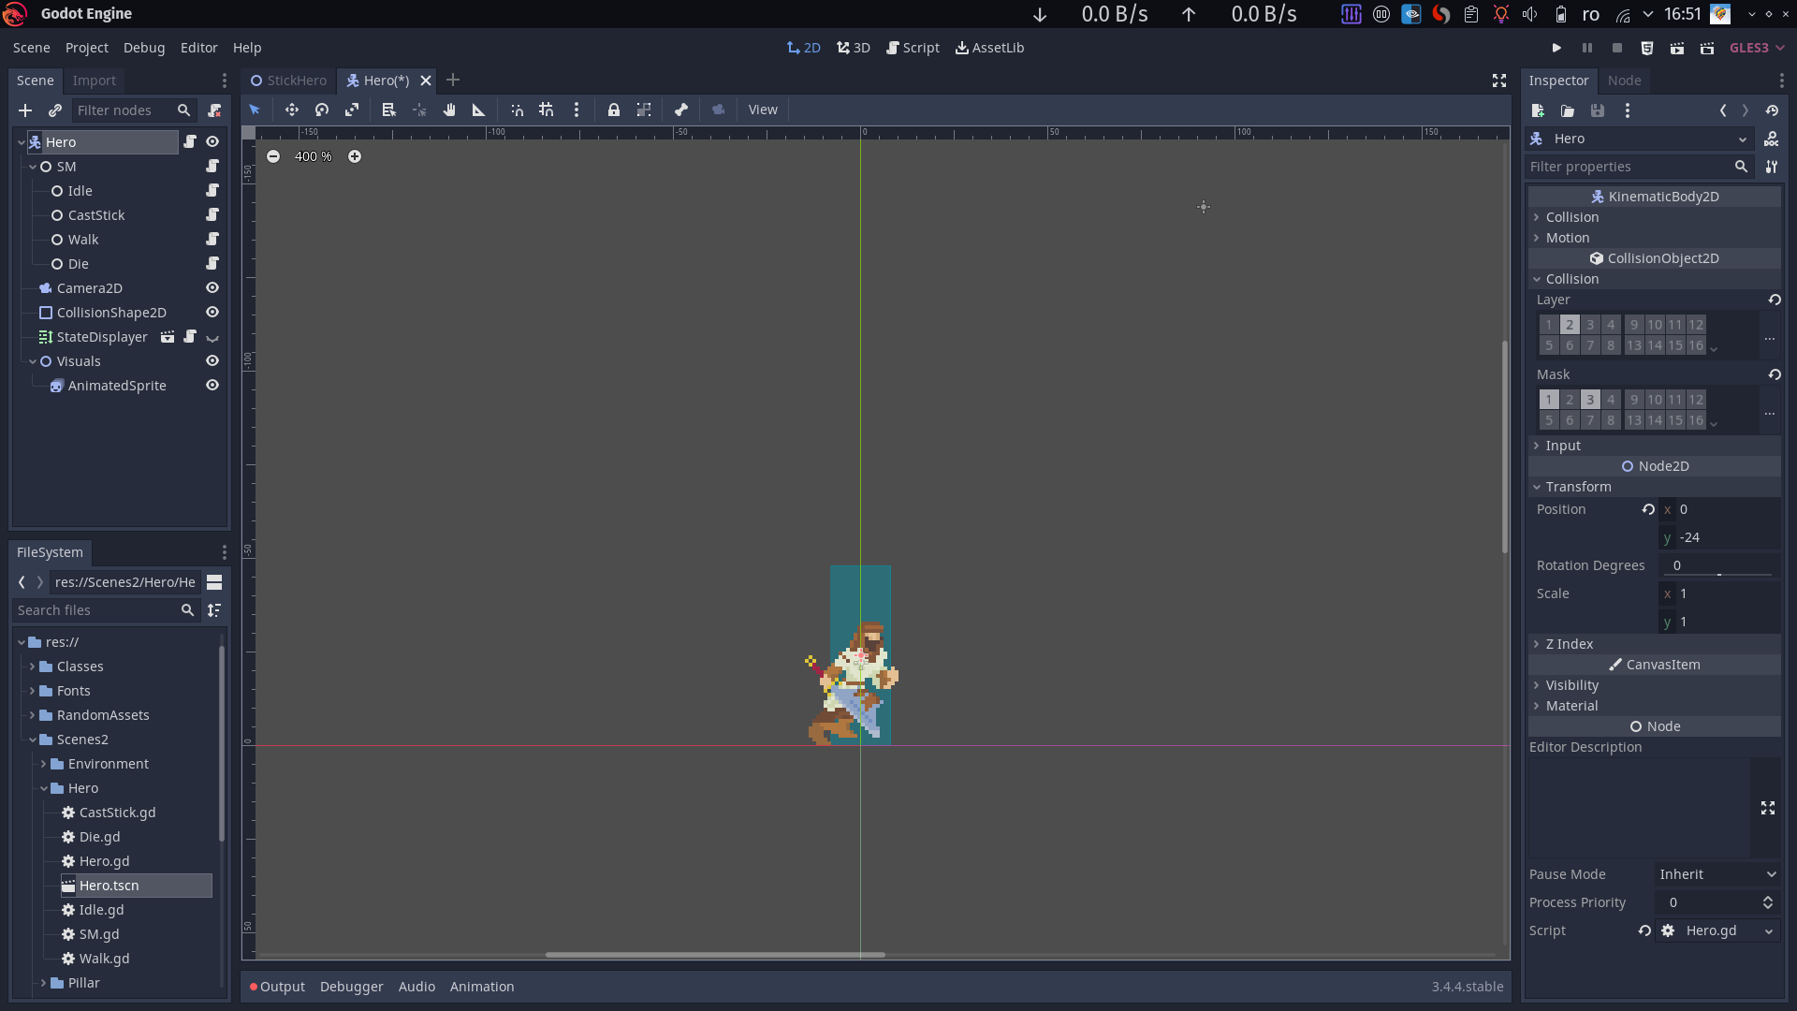
Scena este alcătuita din mai multe noduri fiecare având un rol bine definit.

Nodul-rădăcină(“Hero”) este unul de tip KinematicBody2D.

Scriptul atasat acestuia este responsabil de comportamentul specific al caracterului principal mosteneste clasa predefinita KinematicBody2D.

Scriptul Hero.gd atasat scenei Hero.tscn :

extends KinematicBody2D

onready var sm=get_node("SM")
onready var map=get_parent().get_node("Map")
onready var collision_shape=$CollisionShape2D
onready var aspr=$Visuals/AnimatedSprite

var speed:=200
var vel:=Vector2.ZERO

func do_idle():
sm.request_state("Idle")

func walk_left():
vel.x=200

func _physics_process(delta):
vel.y+=10
vel=move_and_slide(vel, Vector2.UP)

Aceasta este relativ simpla si se ocupă de interacțiunea cu mediul înconjurător al caracterului prin funcția move_and_slide.

Acțiunile propiu-zise ale personajului sunt controlate printr-o “mașină de stări”.
Scriptul StateMachine.gd atașat nodul “SM”:

extends Node
class_name StateMachine

var states={}
var active_states=[]

func add_state(x):
states[x.state_name]=x
x.pr=get_parent()

func _ready():
for x in get_children():
add_state(x)
for x in get_children():
if x.active:
request_state(x.state_name)

func _process(delta):
for s in active_states:
var cur=states[s]
var newst=cur.get_transition()

if newst==null:
cur._during_state(delta)
else:
if newst is String:
if newst.begins_with("exit") :
newst.erase(0,"exit".length())
_deactivate(s)
request_state(newst)
elif newst is Array:
for st in newst:
if st=="exit":
_deactivate(s)
else: request_state(st)
pass

func _deactivate(s:String):
active_states.erase(s)
var cur=states[s]
cur.active=false
cur.exit_state(active_states)

func _activate(st:String):
var cur=states[st]
cur.enter_state(active_states)
if !active_states.has(st):
active_states.push_back(st)
cur.active=true

func request_state(st:String)->bool:
var cur=states[st]
if !cur.has_dependecies():
return false
if cur.is_in_conflict():
return false

for s in cur.removing_states:
if active_states.has(s):
_deactivate(s)
_activate(st)
return cur

func request_exit_state(st:String)->bool:
_deactivate(st)
return true
#
func is_active(st:String):
return active_states.has(st)

Aceasta este responsabila de realizarea tranzițiilor intre stările in care se află caracterul si “activarea” altor script-uri atașate nodurilor-copii ale nodului “SM” ce realizează comportamentul specific al personajului in starile respective. Aceste script-uri moștenesc clasa “State”.
State.gd :

extends Node
class_name State

onready var sm=get_parent()
onready var state_name:=self.name
var pr=null

export var active:=false

var parents=0

var conflicting_states=[]
var removing_states=[]
var necessary_states=[] # strings

#copy
func _ready():
conflicting_states=[]
removing_states=[]
necessary_states=[]

func get_transition():
return null

func enter_state(old_states):
pass

func exit_state(new_states):
pass

func _during_state(delta):
pass
#

func activate():
active=true
enter_state(false)
sm.request_state(state_name)

func deactivate():
active=false
exit_state(false)

func has_dependecies()->bool:
for x in necessary_states:
if !sm.active_states.has(x):
return false
return true

func is_in_conflict()->bool:
for x in conflicting_states:
if sm.active_states.has(x):
return true
return false

Copii nodului “SM” se numesc “Walk”, “CastStick”, “Idle” si “Die”. Si fiecare reprezinta starile posibile are personajului.

Scriptul, Walk.gd, ce se ocupă de mersul caracterului, arată astfel:

extends State

var do_idle:=false
signal idle

func _ready():
connect("idle", self, "_idle")
conflicting_states=[]
removing_states=[]
necessary_states=[]

func get_transition():
if pr.position.y>200:
return ["Die", "exit"]
if do_idle:
do_idle=false
return ["Idle","exit"]
return null

func enter_state(old_states):
pr._ready()
pr.aspr.play(name)

func exit_state(new_states):
pass

func _during_state(delta):
pass
#
Remarcați că anumite functii specifice clasei State sunt suprascrise in acest script(ca si in celelalte script-uri ce definesc stările caracterului). Acestea sunt cele responsabile de realizarea tranzitiei din aceasta stare in starile “Idle” si “Die”( get_transition ), cea de a reda animatia de mers ( enter_state ), _during_state, exit_state si exit_state.
Personajul mai are alte 3 astfel de stari reprezentate de scripturile Idle.gd(activa atunci cand caracterul stationeaza), Die.gd(prezenta atunci cand jocatorul pierde nivelul), CastStick.gd(prezenta atunci cand jucatorul apasa space si ridica “batul”.
Tranzițiile intre aceste stari pot fi reprezentate printr-un graf:
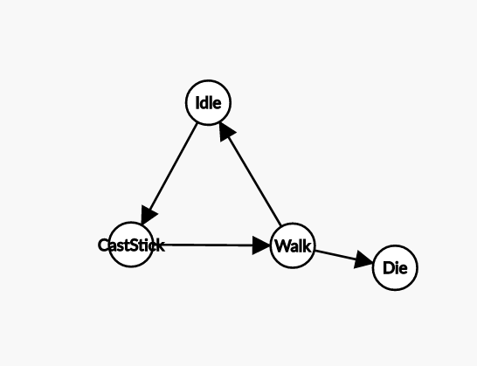

Caracterul incepe in “Idle”, din “Idle” poate sa punta un bat trecand in “CastStick”, bat pe care merge, activand starea “Walk”. Dacă bățul are mărimea potrivita acesta poate sa meargă până se oprește, intrând in Idle altfel cade de pe băț si moare, activand starea “Die”.
Acesta este codul pentru aceste stari :
Die.gd :
extends State

var play_tscn=preload("res://Scenes2/Play/Play.tscn")
#copy
func _ready():
conflicting_states=[]
removing_states=[]
necessary_states=[]

func get_transition():
return null

func enter_state(old_states):
get_tree().root.get_child(0).add_child(play_tscn.instance())
pass

func exit_state(new_states):
pass

func _during_state(delta):
pass

CastStick.gd:
extends State

onready var stick_tscn=preload("res://Scenes2/Stick/Stick.tscn")
var stick_fallen:=false

#copy
func _ready():
conflicting_states=[]
removing_states=[]
necessary_states=[]

func get_transition():
if stick_fallen==true:
stick_fallen=false
return "Walk"
return null

func _stick_fallen():
stick_fallen=true

func enter_state(_old_states):
pr.aspr.play(name)

var stick=stick_tscn.instance()
var shape_extent=pr.collision_shape.shape.extents
stick._ready()
stick.global_position=Vector2(pr.position.x+shape_extent.x+stick.collision_shape.shape.extents.x+0.4-50,stick.position.y)
stick.connect("stick_fallen", self, "_stick_fallen")
pr.get_parent().add_child(stick)

func exit_state(_new_states):
pass

func _during_state(_delta):
pass

Idle.gd :
extends State

func _ready():
conflicting_states=[]
removing_states=["Walk"]
necessary_states=[]

func get_transition():
if Input.is_action_just_pressed("stick"):
return ["CastStick","exit"]

return null

func enter_state(old_states):
pr.aspr.play(name)
pr.vel=Vector2.ZERO
pass

func exit_state(new_states):
pass

func _during_state(delta):
pass

Nodul “Camera2D” reprezinta camera jocului si este parentată eroului pentru a-l urmări pe acesta.

Nodul “CollisionShape2D” este forma de coliziune a personajului, fiind setată să fie un dreptunghi:

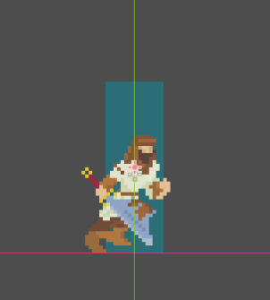

Nodul “Visuals” are parentat la el nodul “AnimatedSprite” ce contine animatiile pentru caracter:

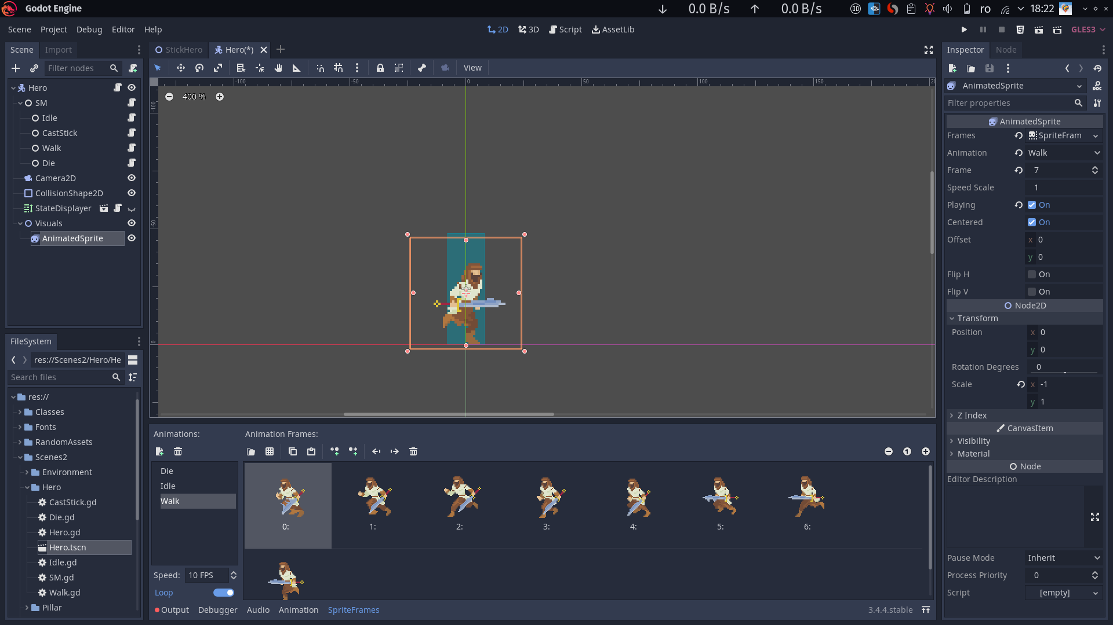

Se mai remarca un nod care este defapt o scena numita “StateDisplayer” :

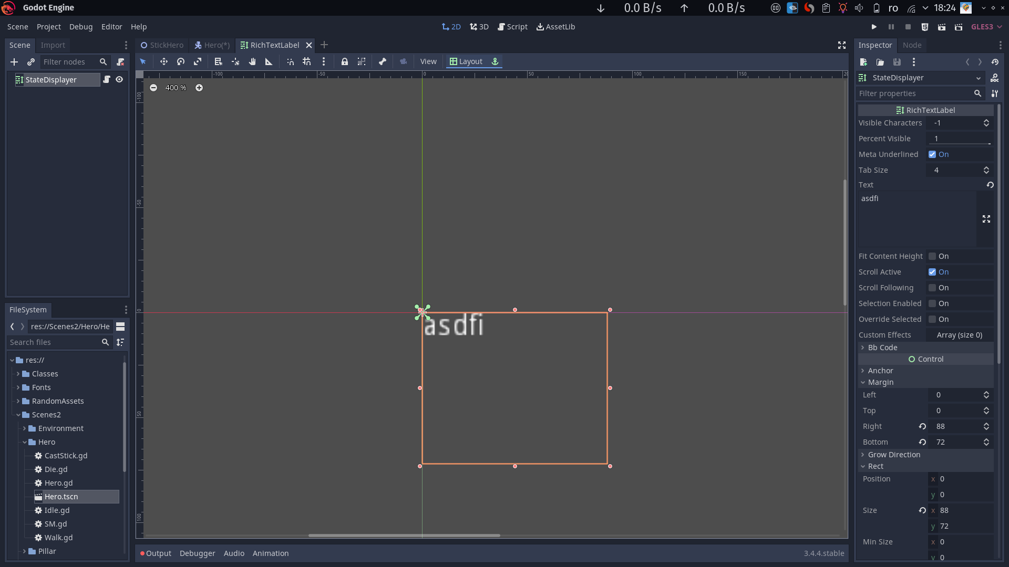

Aceasta afișeaza stările active in mașina de stari.
Scriptul StateDisplayer.gd:
extends RichTextLabel

onready var sm=get_parent().get_node("SM")

func _process(delta):
text=String(sm.active_states)

Atunci cand eroul intra in starea “CastStick” prin apasarea tastei SPACE in starea “Idle” acesta adaugă un “băț” in Scena principală:

Scena Stick.tscn:
[gd_scene load_steps=10 format=2]

[ext_resource path="res://Scenes2/Stick/Stick.gd" type="Script" id=1]
[ext_resource path="res://Scenes2/Stick/SM.gd" type="Script" id=2]
[ext_resource path="res://Scenes2/Stick/Grow.gd" type="Script" id=3]
[ext_resource path="res://Scenes2/Stick/Fall.gd" type="Script" id=4]
[ext_resource path="res://Classes/StateMachine/StateDisplayer/RichTextLabel.tscn" type="PackedScene" id=5]
[ext_resource path="res://RandomAssets/Squares/white.png" type="Texture" id=6]
[ext_resource path="res://Scenes2/Stick/Particles2D.gd" type="Script" id=7]

[sub_resource type="RectangleShape2D" id=1]
extents = Vector2( 8, 8 )

[sub_resource type="ParticlesMaterial" id=2]
lifetime_randomness = 0.6
flag_disable_z = true
spread = 180.0
gravity = Vector3( 0, 97, 0 )
initial_velocity = 50.0
initial_velocity_random = 0.2
orbit_velocity = 0.0
orbit_velocity_random = 0.0
scale = 5.0
scale_random = 0.5

[node name="Stick" type="KinematicBody2D"]
collision_layer = 4
collision_mask = 0
script = ExtResource( 1 )

[node name="Sprite" type="Sprite" parent="."]
scale = Vector2( 0.25, 0.5 )
texture = ExtResource( 6 )
offset = Vector2( 16, -16 )

[node name="CollisionShape2D" type="CollisionShape2D" parent="."]
modulate = Color( 1, 0, 0, 1 )
position = Vector2( 8, -8 )
shape = SubResource( 1 )
disabled = true

[node name="SM" type="Node" parent="."]
script = ExtResource( 2 )

[node name="Grow" type="Node" parent="SM"]
script = ExtResource( 3 )
active = true

[node name="Fall" type="Node" parent="SM"]
script = ExtResource( 4 )

[node name="StateDisplayer" parent="." instance=ExtResource( 5 )]
visible = false

[node name="Tip" type="Position2D" parent="."]
position = Vector2( 3.994, -16 )

[node name="Node" type="Node" parent="."]

[node name="Particles2D" type="Particles2D" parent="Node"]
position = Vector2( 3.99426, -16 )
amount = 1000
lifetime = 46.9
speed_scale = 2.0
randomness = 1.0
fixed_fps = 60
local_coords = false
process_material = SubResource( 2 )
script = ExtResource( 7 )

Scena Stick.tscn in editor:

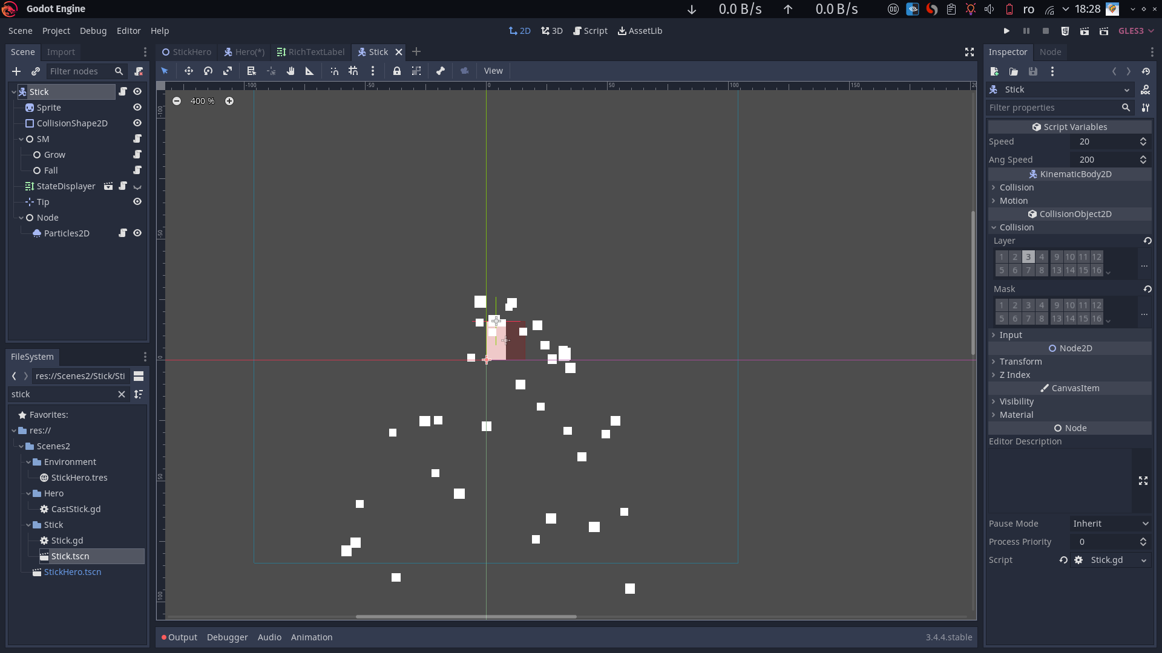
Se remarcă folosirea aceleiași implementări a mașinii de stări și în cadrul acestei scene care are ca stari “Grow” si “Fall”. Atunci cand este introdus in scena principala Bățul se află in starea “Grow” iar atunci cand jucatorul nu mai apasa tasta SPACE aceasta intra in starea “Fall”.
Scriptul Grow.gd:
extends State

func _ready():
conflicting_states=[]
removing_states=[]
necessary_states=[]

func get_transition():
if !Input.is_action_pressed("stick"):
return ["Fall","exit"]
return null

func enter_state(old_states):
pass

func exit_state(new_states):
pass

func _during_state(delta):
pr.scale.y+=pr.speed*delta
#

Scriptul Fall.gd:
extends State

#copy
func _ready():
conflicting_states=[]
removing_states=[]
necessary_states=[]

func get_transition():
if pr.rotation_degrees==90:
return ["exit"]
return null

func enter_state(old_states):
pr.particles.emitting=false
pass

func exit_state(new_states):
pr.collision_shape.disabled=false
pr.emit_signal("stick_fallen")

func _during_state(delta):
pr.rotation_degrees+=pr.ang_speed*delta
pr.rotation_degrees=min(pr.rotation_degrees,90)

Pe langa “eroul” acestui joc am realizat o harta generata procedural. Aceasta consta in niste stalpi pe care acesta poate sa mearga si niste marcare invizibile care au rolul.

BIBLIOGRAFIE

- https://docs.godotengine.org/en/stable/

5-6 LUCRARI

CUPRINS

